HW 8 Measurements:

tsu= 970ps (compared to 210ps from schematic simulation)

Simulation code used:

VGND GND 0 DC 0,VVDD VDD 0 DC 5,

VCLK CLK 0 DC 0 PULSE 0 5 0 10p 10p 3n 6n,

VIN D 0 DC 0 PULSE 5 0 200p 10p 10p 3n 5.99n,

.include c5.txt,.tran 2000n UIC,

.save v(rd) v(ck) v(q) v(qbar) v(D_FF@2:D_latch@0:x) v(D_FF@2:outbar) v(D_FF@2:D_latch@1:x) v(D_FF@2:mid) dialogbox,

*.options post

Screenshot of area measured:

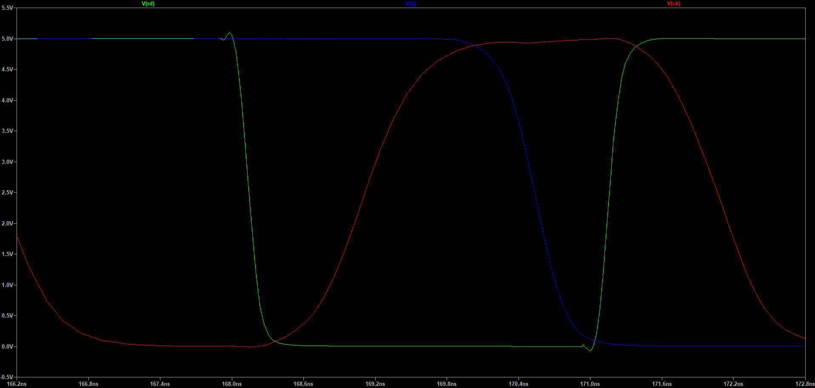

Part 2:

tcqr = 565ps (compared to 282ps from schematic simulation)

Area measured:

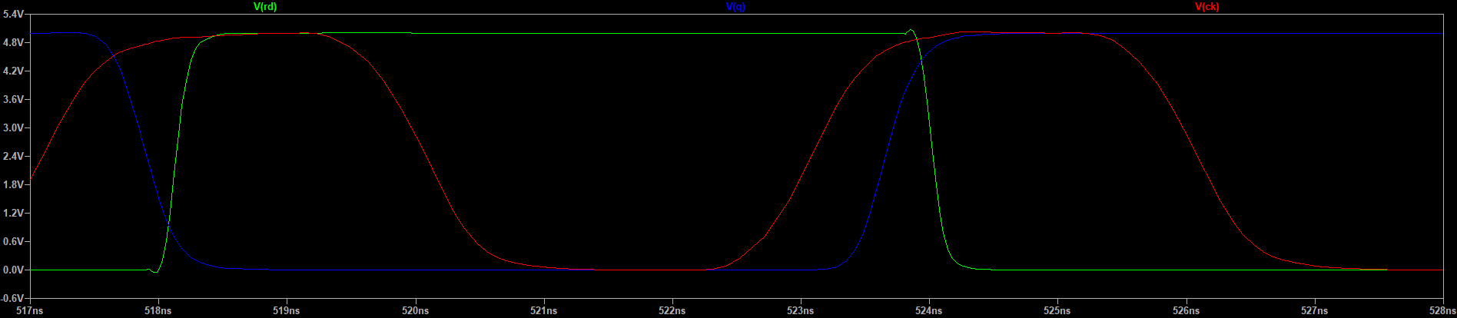

tcqf = 781ps (compared to 295ps from schematic simulation)

Area measured:

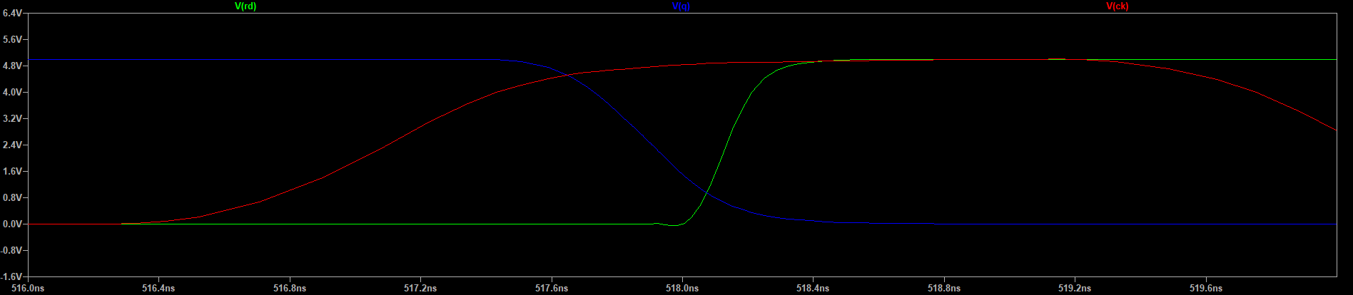

Simulation code used:

VGND GND 0 DC 0,VVDD VDD 0 DC 5,

VCLK CLK 0 DC 0 PULSE 0 5 0 10p 10p 3n 6n,

VIN D 0 DC 0 PULSE 5 0 200p 10p 10p 6n 11.99n,

.include c5.txt,.tran 2000n UIC,

.save v(rd) v(ck) v(q) v(qbar) v(D_FF@2:D_latch@0:x) v(D_FF@2:outbar) v(D_FF@2:D_latch@1:x) v(D_FF@2:mid) dialogbox,

*.options post